
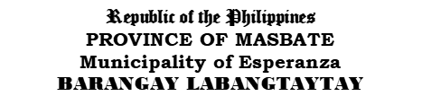


TO WHOM IT MAY CONCERN:

This is to certify that ______________________________, ____ of legal age, is a ( ) permanent, ( ) temporary,
( ) renter, a bonafide resident of Purok ____, Barangay Labangtaytay, Esperanza, Masbate.
He/She has no pending case/complaint against him/her as per record of this office. He/She has no derogatory record file in this office.

This certification is being issued by this office upon the request of aforementioned name for:

( ) Proof of Residency ( ) Local Employment ( ) Travel Abroad

( ) Postal I.D ( ) Bank Requirement ( ) NBI Clearance

( ) Loan Purpose ( ) Medical/Financial Assistance ( ) Others:_____________________

Given today ____ day of _____, 2026 at Barangay Labangtaytay, Esperanza, Masbate, Philippines.

JORGE C. BRUZA
Punong Barangay

Released by:

JENNETH A. CACHILA
Barangay Secretary
(Residency certificate valid three (3) months from the date of issuance)

Not Valid without Barangay Seal

